PES Institute of Technology
& Management
NH-206, Sagar Road, Shivamogga



DEPARTMENT OF COMPUTER SCIENCE AND
ENGINEERING

Assignment On

Flow of Energy and Resource availability in eco system

Environmental studies and E waste management
(BCS508)
SUBMITTED BY

Name of the Student: GAGAN R N
USN: 4PM22CS040 Branch: CSE

Academic Year 2024-25
5th Semester

Date of Submission: 12/12/2024
Signature of the Student:
Maximum Marks: 25
Marks Awarded:
Signature of Course Instructor:

Abstract

This report explores energy flow in ecosystems and its critical link to resource availability, consumption, and sustainable development. Solar energy, captured by producers, drives biodiversity and ecosystem health but faces threats from overconsumption and environmental degradation.

Through case studies, it highlights the consequences of unsustainable practices, such as habitat loss and climate change, while advocating for integrated approaches aligned with the Sustainable Development Goals (SDGs). The report emphasizes the need for balancing human needs with environmental integrity through sustainable resource management, innovation, and policy reforms to secure a prosperous and resilient future.

Table of Contents
- Introduction
- Flow of Energy in Ecosystems
  - 2.1 Definition
  - 2.2 Trophic Levels
  - 2.3 Energy Transfer Efficiency
  - 2.4 Role of Decomposers
- Resource Availability and Consumption
  - 3.1 Natural Resources
  - 3.2 Sustainable Resource Management
  - 3.3 Impact of Overconsumption
- Interconnection Between Energy Flow and Resource Consumption
  - 4.1 Ecosystem Health
  - 4.2 Sustainable Development Goals (SDGs)
- Case Studies
  - 5.1 Energy Flow in Forest Ecosystems
  - 5.2 Resource Management in Aquatic Ecosystems
- Conclusion
- Recommendations
- References

Introduction
Sustainable development aims to balance economic growth, environmental protection, and social equity, with a key focus on energy flow in ecosystems and resource management. This report highlights the interconnections between these elements and their role in maintaining ecological balance and promoting sustainability.
Energy flow in ecosystems underscores the interdependence of organisms and the critical link between resource management and planetary health. Unsustainable practices jeopardize biodiversity and human well-being, emphasizing the urgent need for sustainable strategies to protect the environment and ensure long-term resilience

Flow of Energy in Ecosystems

Definition
The flow of energy in ecosystems describes the transfer of energy across trophic levels, beginning with solar energy captured by producers and moving through various organisms in the food chain. This process is vital for sustaining ecosystem structure and function, as it drives the growth, reproduction, and survival of organisms while supporting critical processes like nutrient cycling and ecological stability.

Trophic Levels
Ecosystems are structured in a hierarchical manner, with different levels of organisms categorized based on their role in energy transfer:
- Producers (Autotrophs): These organisms, primarily green plants and phytoplankton, convert solar energy into chemical energy through photosynthesis. They form the base of the food web and are essential for providing energy to other organisms.
- Consumers (Heterotrophs): These organisms obtain energy by consuming other organisms. They are categorized into:
- Primary Consumers: Herbivores that feed on producers.
Examples include rabbits, deer, and insects.
- Secondary Consumers: Carnivores that eat herbivores. Examples include snakes and birds of prey.
- Tertiary Consumers: Top predators that feed on other carnivores.
Examples include eagles and large cats.

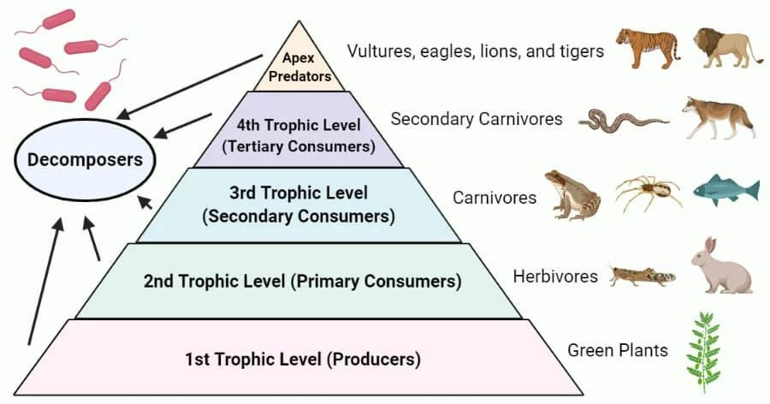

Energy Transfer Efficiency
The transfer of energy between trophic levels is highly inefficient, with approximately 90% of energy lost as heat or consumed in metabolic processes, a concept known as the "10% Rule." According to this rule, only about 10% of the energy from one trophic level is passed on to the next. For example, if a plant captures 1000 joules of solar energy, only about 100 joules are available to primary consumers, and a mere 10 joules to secondary consumers.
This significant energy loss restricts the number of trophic levels an ecosystem can sustain, shaping food web dynamics and limiting the overall productivity of ecosystems. It highlights the critical role of primary producers in capturing and storing solar energy to support higher levels in the food

Role of Decomposers
Decomposers, such as fungi and bacteria, are essential to ecosystem sustainability, breaking down dead organic matter and recycling nutrients back into the soil. By converting complex organic materials into simpler, bioavailable substances, they facilitate nutrient cycling, ensuring that producers have the resources needed for growth. This process not only supports the regeneration of plant life but also enhances soil health, fertility, and overall ecosystem stability. Decomposers are the cornerstone of energy recycling, enabling ecosystems to maintain their productivity and resilience over time.

Resource Availability and Consumption

Natural Resources
Natural resources, including water, minerals, fossil fuels, and biodiversity, are essential for human survival and economic development. Their availability directly influences energy consumption patterns and overall ecosystem health. The sustainable management of these resources is critical for ensuring that they remain available for future generations.

Sustainable Resource Management
Effective management of natural resources is crucial for ensuring their availability for future generations. Sustainable practices include:
- Conservation: Protecting natural habitats and ecosystems to maintain biodiversity and ecosystem services. This can involve establishing protected areas, restoring degraded ecosystems, and implementing sustainable land-use practices.
- Recycling: Reducing waste and reusing materials to minimize the extraction of new resources. Recycling programs can significantly decrease the demand for raw materials and reduce environmental impacts.
- Renewable Resources: Promoting the use of solar, wind, and other renewable energy sources to reduce dependence on fossil fuels.
Transitioning to renewable energy can help mitigate climate change and reduce environmental degradation.
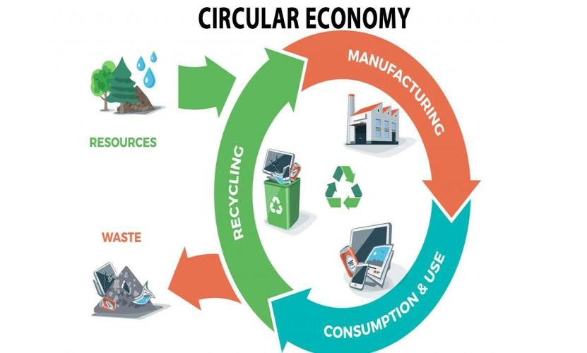

Impact of Overconsumption
Unsustainable consumption patterns can lead to resource depletion, environmental degradation, and loss of biodiversity. These impacts disrupt the natural flow of energy in ecosystems, leading to ecological imbalances. For example, overfishing can deplete fish populations, disrupting marine food webs and affecting the livelihoods of communities that depend on these resources. Similarly, deforestation can lead to habitat loss, increased carbon emissions, and reduced biodiversity, further exacerbating climate change and its associated impacts.
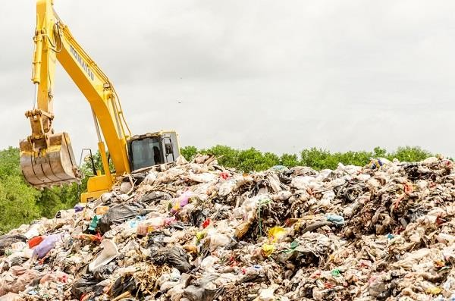

Interconnection Between Energy Flow and Resource Consumption

Ecosystem Health
The health of an ecosystem is determined by the balance of energy flow and resource availability. Disruptions in either can lead to negative consequences, such as habitat loss, species extinction, and reduced ecosystem services. Healthy ecosystems provide essential services, including clean air and water, pollination of crops, and climate regulation, which are vital for human well-being.

Sustainable Development Goals (SDGs)
Understanding the flow of energy and resource consumption is essential for achieving the United Nations Sustainable Development Goals (SDGs). Key goals related to this topic include:
- Goal 7: Ensure access to affordable, reliable, sustainable, and modern energy for all. This goal emphasizes the need for increased investment in renewable energy sources and energy efficiency measures.
- Goal 12: Ensure sustainable consumption and production patterns. This goal focuses on promoting resource efficiency and reducing waste throughout the production and consumption cycle.
- Goal 15: Protect, restore, and promote sustainable use of terrestrial ecosystems. This goal highlights the importance of managing forests, combating desertification, and halting biodiversity loss.

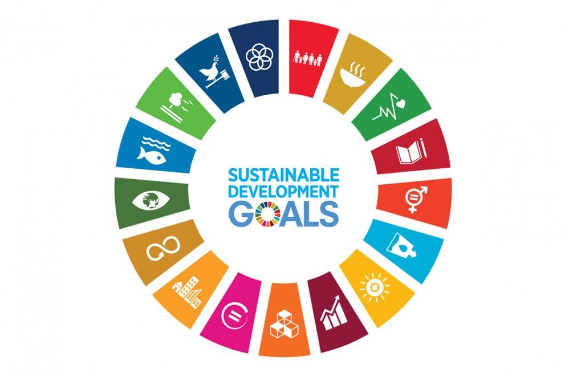

Case Studies

Energy Flow in Forest Ecosystems
Forests are complex ecosystems that demonstrate the intricate flow of energy. In a forest ecosystem, sunlight is captured by trees (producers) through photosynthesis, which forms the basis of the food web. Herbivores, such as deer and insects, consume the foliage, while carnivores, such as wolves and birds of prey, feed on these herbivores. The decomposition of organic matter by fungi and bacteria returns nutrients to the soil, supporting new plant growth. Sustainable forest management practices, such as selective logging and reforestation, are essential for maintaining the health of these ecosystems and ensuring their continued ability to provide resources and services.
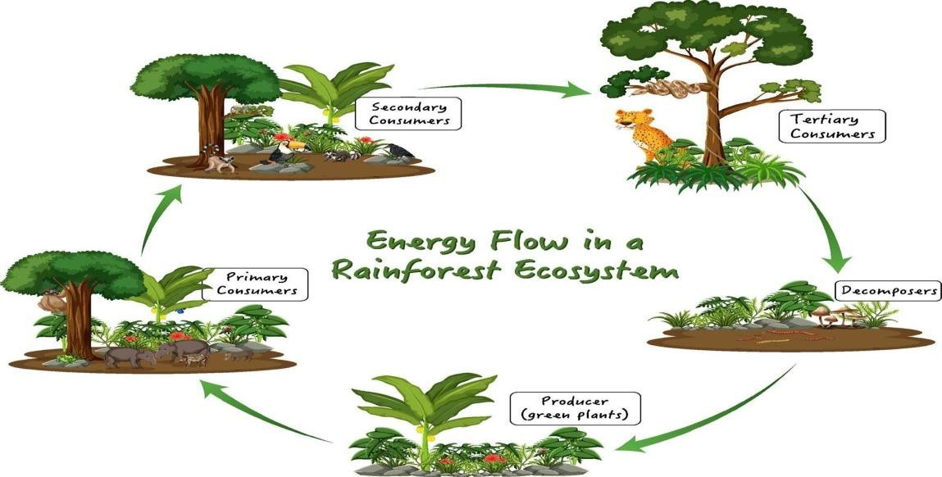

Resource Management in Aquatic Ecosystems
Aquatic ecosystems, including rivers, lakes, and oceans, are vital for biodiversity and human livelihoods. The flow of energy in these ecosystems is influenced by factors such as water temperature, nutrient availability, and light penetration. Overfishing and pollution can severely impact aquatic food webs, leading to declines in fish populations and the degradation of water quality. Sustainable practices, such as establishing marine protected areas and implementing catch limits, are crucial for preserving these ecosystems and ensuring the availability of resources for future generations.

Conclusion
The flow of energy in ecosystems, along with the patterns of resource availability and consumption, forms the foundation of sustainable development.
Understanding these interconnected processes is vital for fostering practices that safeguard ecosystem health and ensure the responsible use of resources. By aligning human activities with ecological principles, we can strike a balance between meeting present needs and preserving environmental integrity. This approach not only supports biodiversity and ecosystem resilience but also secures the well-being of current and future generations, paving the way for a truly sustainable future.

Recommendations
- Education and Awareness: Integrate education on energy flow, resource management, and sustainability into school curricula and community programs to cultivate environmental consciousness and a culture of sustainability across generations.
- Policy Development: Advocate for comprehensive government policies that prioritize sustainable resource management, energy efficiency, and the transition to renewable energy sources, supported by incentives and robust enforcement mechanisms.
- Research and Innovation: Drive investment in cutting-edge research to develop advanced technologies and methodologies for improving energy efficiency and resource conservation. Focus on scalable, innovative solutions to mitigate environmental challenges and enhance sustainability.
- Community Engagement: Actively involve local communities in resource management decisions, leveraging their indigenous knowledge and addressing their unique needs. This participatory approach fosters collaboration, accountability, and a shared commitment to sustainable practices.
- Monitoring and Evaluation: Implement dynamic systems to monitor and assess the impact of sustainable initiatives, enabling data-driven
adjustments and continuous improvement. These systems ensure that policies and practices remain effective and responsive to changing environmental and social conditions.

References
- United Nations (2015): Transforming Our World: The 2030 Agenda for Sustainable Development outlines 17 goals for eradicating poverty, protecting the planet, and ensuring global prosperity.
- Odum, E. P. (1971): Fundamentals of Ecology provides a foundational understanding of energy flow and ecosystem dynamics.
- Daily, G. C. (1997): Nature's Services highlights the vital ecosystem services supporting human life and the need for their conservation.
- Millennium Ecosystem Assessment (2005): Ecosystems and Human Well-being links ecosystem health to human welfare, advocating sustainable management.

